**Instructions on how to run your automated tests;** See the following steps

1. Launch the Test Automation Framework(Appium)
2. Set valid parameters( eg deviceName, platformName, appPackage, appActivity etc) 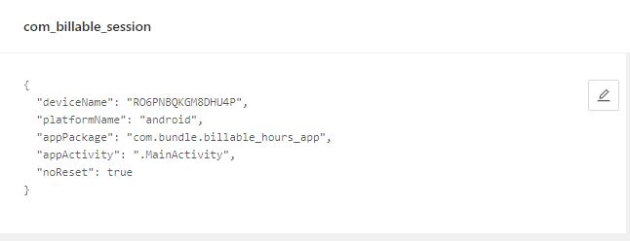
3. Start Sessions
4. Import valid packages and Libraries from the following (Java client, Selenium hq, lang 3)
5. Inspect Elements
6. Selects elements to ensure valid response
7. Create the object class of DesiredCapabilities
8. Copy the source code from **Appium** into **intelliJIDEA** into the **src** file
9. Then run the Application to see Results.

See below Appium screens;

